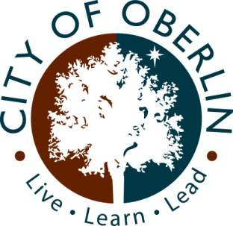

OBERLIN COMMUNITY
IMPROVEMENT CORPORATION (OCIC)

OBERLIN BUSINESS LOAN PROGRAM
GUIDELINES AND APPLICATION

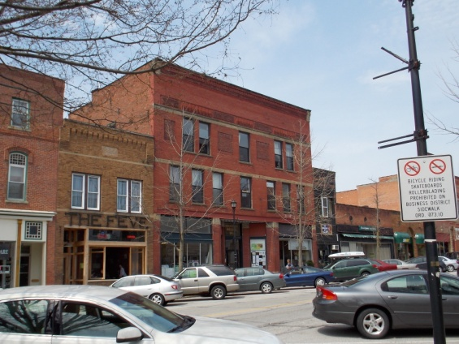

Revised March 8, 2022

OCIC OBERLIN BUSINESS LOAN
PROGRAM GUIDELINES

I. INTRODUCTION

The Oberlin Community Improvement Corporation (OCIC) is investing in the revitalization of Oberlin, to enhance the local economy and to stimulate industrial and commercial investments, as well as residential development, within the City. The Oberlin Community Improvement Corporation further believes that such an investment program will promote further investment and will also create and retain jobs within the community. For these reasons, the Oberlin Community Improvement Corporation has initiated a program to loan monies to property owners or business owners for the purpose of creating and/or retaining jobs in the City of Oberlin

II. THE PROGRAM

The Program consists of the OCIC providing loans to eligible businesses located within the city limits for the purpose of remodeling or renovating an existing building, or the purchase of new or used equipment. Loans are based on the availability of funds and are made on a “first come, first served” basis.

The OCIC will loan funds at one percent (1%) interest for a maximum of five (5) years. The minimum loan amount is $1,000.00. The loan will cover a maximum of eighty percent (80%) of the approved costs and to, generally, a maximum of Ten Thousand Dollars ($10,000.00). OCIC retains the absolute authority and discretion in determining the amount and terms of the loan that the applicant shall receive. Further, OCIC may authorize loans in an amount greater than Ten Thousand Dollars ($10,000.00) upon a showing of unusual or extraordinary circumstances that necessitate additional expenses.

Lastly, the Oberlin Business Loan Program cannot be used for work that was started, or for equipment that was purchased prior to approval and the loan documents being fully executed.

III. ELIGIBILITY

Eligible loan program participants include owners of buildings or businesses located within the city limits of the City of Oberlin and zoned C-1, C-2, C-3, or M-1 by the Oberlin Zoning Code. The OCIC reserves the right to request such documentation as to ownership of the structure or business for which the loan is requested as the OCIC deems necessary and in the case of business owners, authorization by the property owner to file the application. If the applicant does not fully cooperate with OCIC in this regard the application will no longer be considered.

IV. WHERE TO FILE

Applications for the Oberlin Business Loan Program must be submitted on the prescribed form with all pertinent documentation provided. The application must be submitted to the Secretary of the OCIC at Old City Hall, 69 South Main Street, Oberlin, Ohio, during regular business hours of 8:00 a.m. to 4:30 p.m., Monday through Friday. The application shall be “date-stamped” upon receipt. Arrangements can also be made to send the application and documentation via electronic mail by calling the Secretary of the OCIC at 440-775-7250.

- CONTENTS OF APPLICATION

The application shall be fully completed with all requested information provided with same. If applicable, the application shall be accompanied by an architectural rendering of the proposed renovations, drawn to scale, which shall include all proposed signage and color schemes. The application shall include verification of Planning Commission approval if required. The application shall also be accompanied by two (2) bonafide estimates of the cost of the proposed renovations and/or equipment, which shall be sufficiently specific to allow the OCIC to compare costs and to review the materials proposed to be used in the project.

OCIC reserves the right to request additional information if it deems the application information is not sufficient to make a decision upon the loan. Any refusal by the applicant to fully cooperate with the OCIC concerning any request for additional information shall be cause for immediate rejection of the application.

VI. APPROVAL PROCEDURE

Applicants shall be processed in the order that they are received by OCIC. Applications will be deemed received as of the date that they are submitted to the Secretary of the OCIC at Old City Hall. As the funds available for these loans are limited, requests will be processed on a “first come, first served” basis, until the loan funds are exhausted. The OCIC will appoint a Committee of its members to review the applications and to make a recommendation on the same. The OCIC has the absolute authority to accept or reject any application that the Committee considers to be unacceptable. The decision of the OCIC shall be final.

Any revision to the application must be approved by the OCIC Loan Committee. The OCIC Loan Committee shall recommend to the full OCIC Board the amount of the loan that the applicant shall receive, if any, and the other terms and conditions of the loan.

VII. TERMS AND CONDITIONS OF THE LOAN

Once an applicant has been successful in obtaining approval from the OCIC Board for a loan under the Oberlin Business Loan Program, the applicant shall execute a loan agreement which shall address the following conditions:

1. The loan amount, which is generally no more than $10,000.00, unless the OCIC Board finds a compelling reason to exceed this amount.

2. The loan proceeds shall be used exclusively for the remodeling/renovation of buildings, or for the purchase of new or used equipment for businesses located within the city limits of Oberlin.

3. The applicant certifies to the OCIC that it is the fee simple title holder of the property upon which the loan proceeds are being expended or in the case of a business owner, that the property owner has authorized the application.

4. The applicant certifies that the loan proceeds will constitute no more than eighty percent (80%) of the funding for the project.

5. Counsel for O.C.I.C. shall prepare loan documents.

6. The renovation project or the equipment purchase shall be completed within one (1) year of the date of loan approval by the OCIC Board, unless an extension for a maximum of six (6) months is approved by the Board.

7. The loan shall be repaid in monthly installments to the Oberlin Community Improvement Corporation starting ninety (90) days from the loan approval date. Payments are to be sent to the OCIC Treasurer, 69 S. Main St., Oberlin, OH 44074.

8. All loans will be amortized over a period of not greater than five (5) years from the date that the applicant receives the final payment of the loan proceeds.

9. The applicant shall also execute a Guaranty Agreement, Mortgage, Security Agreement, or such other agreement or document for security for the loan, as may be required by the OCIC Board. All such documents will be prepared by OCIC Counsel and be acceptable to the OCIC Board. Failure to execute any of said documents upon demand shall be cause for immediate rejection of the application and denial of the loan. Any loan made under this program will be called if the business or project activities move from the City. Language to this effect will be included in the note and development agreement.

10. The applicant shall certify that the proposed project is in compliance with all applicable building codes, ordinances and laws of the municipality, the State and the Federal Government.

11. The loan proceeds shall be disbursed in one of two different methods selected by the loan applicant:

- Loan proceeds will be disbursed to the applicant in two (2) installments. The first installment shall be in the amount of fifty percent (50%) of the loan and shall be provided to the applicant when, in the sole opinion of the City’s Chief Building Official has determined construction has started. The final payment of the loan proceeds shall be provided to the applicant when the applicant’s project is, in the opinion of the Chief Building Official one hundred percent (100%) complete.

- Loan proceeds will be disbursed directly to the applicant’s contractors after, in the sole opinion of the City’s Chief Building Official that construction has started and when the project is one hundred percent (100%) complete. Disbursements to contractors will be based on the percentage of loan proceeds in the total project. For example, if the OCIC Oberlin Business Loan is 80% of the total project and a contractor submits an invoice for payment for $1,000, then OCIC would pay that contractor $800 and the applicant would be responsible for paying the remaining $200. The applicant can instead be reimbursed for eligible and approved costs, i.e., equipment and construction costs, so long as the documentation provided also includes proof of payment.

The Board reserves the right to withhold payment should it be determined that the loan monies are not being applied to the project.

12. The applicant shall keep and retain invoices, bills of sale, receipts and other documents which shall clearly indicate how the loan proceeds were spent upon the project. Such documents shall be submitted to the OCIC Treasurer prior to the final disbursement of funds. Those documents shall also be retained by the applicant during the life of the loan and shall be provided to the OCIC upon request.

13. The applicant, by accepting the loan proceeds, or any part thereof, agrees to hold the OCIC, its Board, Committees, employees, and agents, harmless from any and all liabilities or claims caused by or resulting from the applicant’s performance of the obligations or activities in furtherance of the project work or in the receiving of the loan funds. Further, the applicant will reimburse the OCIC for any judgments for findings which may be obtained against OCIC resulting from the project work or the making of such loan. Further, the applicant agrees to defend against any such claims or legal actions if called upon by the OCIC to do so.

- CONFLICT OF INTEREST

No member or employees of the Oberlin Community Improvement Corporation, or members of their families, shall have any interest in, direct or indirect, or be eligible for this loan program.

OCIC BUSINESS LOAN PROGRAM
APPLICATION FORM

Name of Applicant: ______________________________________________________
Applicant’s Business Name (if applicable):_____________________________________
Mailing Address:__________________________________________________________
Telephone No.: 1) Home__________________________
2) Business________________________

Location of property where project is proposed (Municipal Street Number):______________________________________________________________________

Who is the owner of the building?
Name:_______________________________________________________________________
Address: _____________________________________________________________________
Telephone: __________________________

If the owner of the building is a corporation or a partnership, please provide the names, addresses and telephone numbers of all officers or managing partners.

NAME | ADDRESS | TELEPHONE

- What is the total estimated cost of your proposed project?
$____________

- What is the exact amount of the loan that you desire from OCIC? $_____________

- Attach two (2) bonafide estimates of the cost of your proposed project. The estimates must be sufficiently specific to allow the OCIC to review the materials proposed to be used or equipment to be purchased as part of the project.

- Attach an architectural rendering of your proposed restoration if applicable. It must be drawn to scale and include all proposed signage and color schemes.

- Attach a copy of verification that the proposed improvements have been approved by the Planning Commission if applicable.

I hereby certify that the answers to the questions set forth hereinbefore are true and accurate to the best of my belief and knowledge.

Signature of Property Owner or Business Owner Date

I hereby authorize to file an application under the Business Loan Program for property known as municipal number _____________________________.

______________________________________________________________________________ Signature of Property Owner Date

